Lab # 03



Fall 2024

**CSE-310L Control Systems Lab**

Submitted by: MUHAMMAD SADEEQ

Registration No.: 21PWCSE2028

Section: C

“On my honor, as a student of the University of Engineering and Technology, I have neither given nor received unauthorized assistance on this academic work”

Submitted to:

Dr. Muniba Ashfaq

(19 Oct 2024)

Department of Computer systems engineering

University of Engineering and Technology, Peshawar

**Simulation of Differential Equations using MATLAB**

**Task 1**

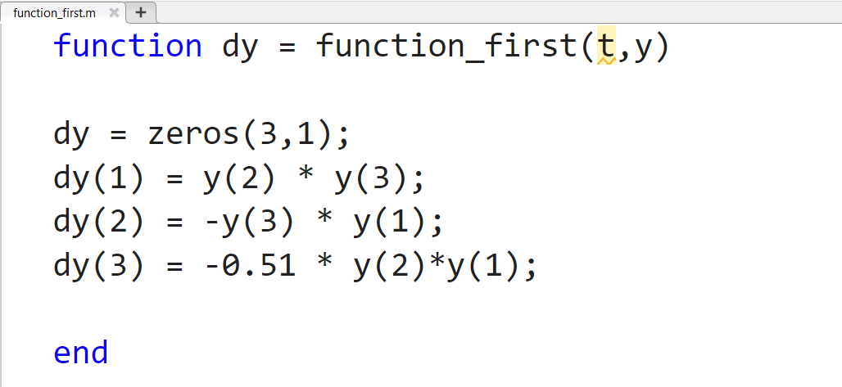

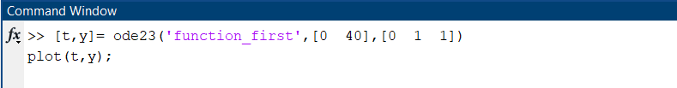

**Output:**

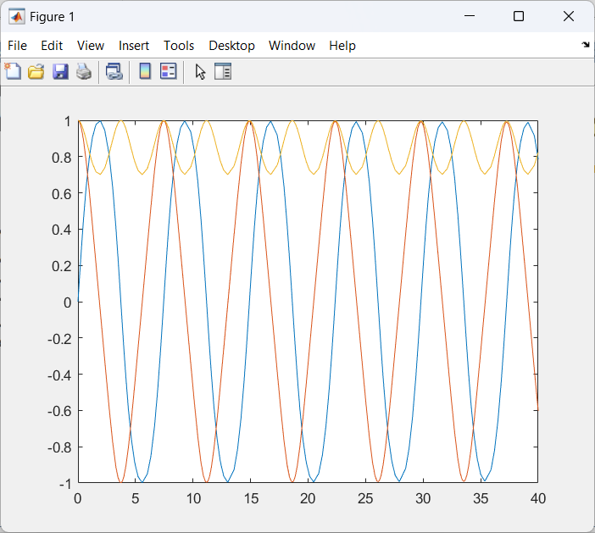

**Task 2**

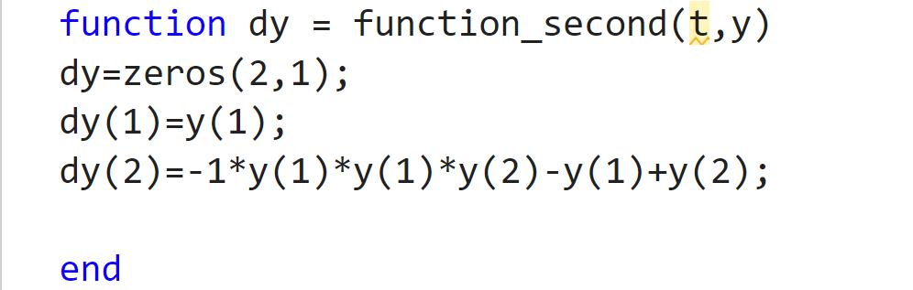

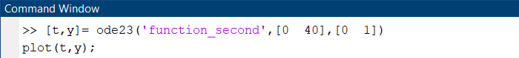

**Output:**

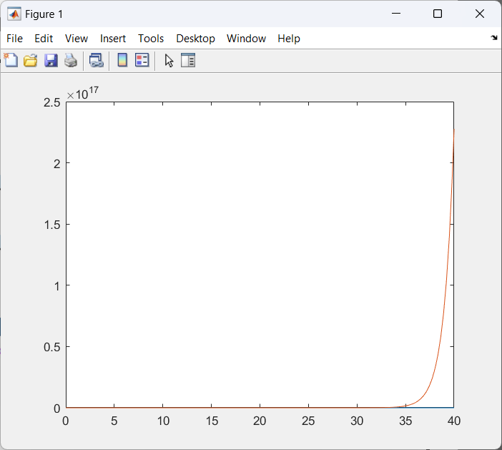

**Simulation of Differential Equations using Simulink**

**Task 1**

**In MATLAB:**

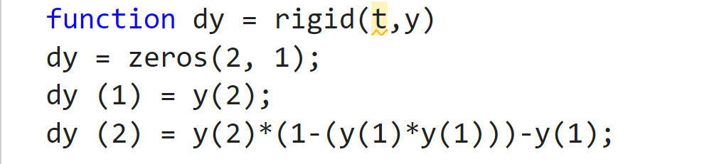

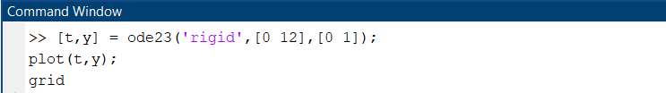

**Output:**

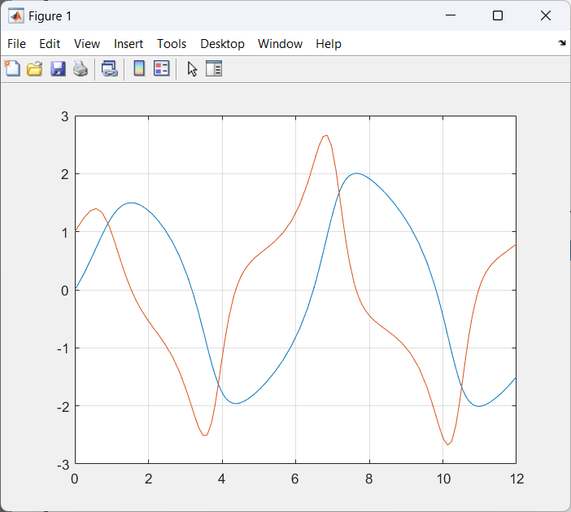

**In Simulink:**

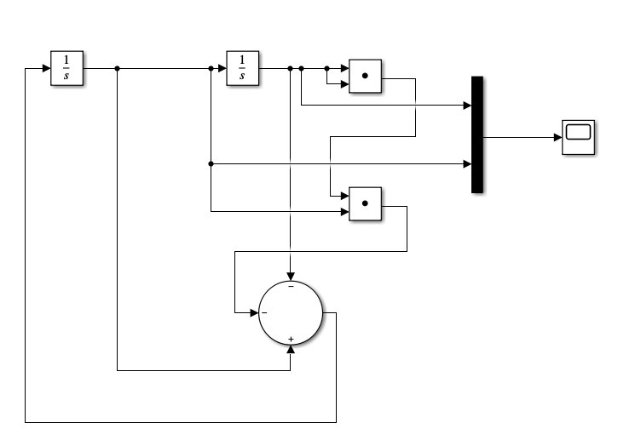

**Output:**

